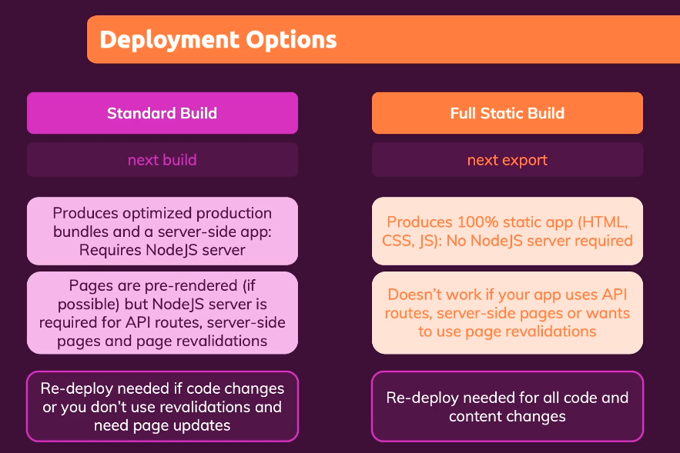 There are 2 types of deployments.

1. Standard Buil

a. Command used “next build” (as npm command)

b. Needs node js environment to run this code

c. Should be used if some dynamically rendered content is present ( getStaticProps → revalidate, fallback to true or blocking

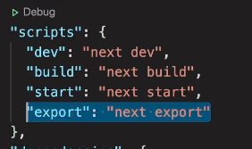2. Full Static Build

a. Command used “next export” (as npm command)

b. Needs node js environment to run this code

c. Should be used if none of dynamically rendered content is present

